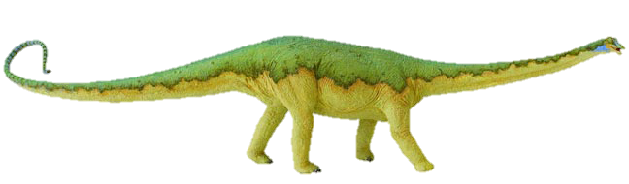
Long and short a sound sort
Sometimes it’s helpful to say that short sounds are short and bouncy, and to make a bouncing ball action as you say them; while long sounds can be stretched, exaggerating the sound slightly, whilst making a stretching elastic kind of movement.
Cut this top row off before you give the sort to pupils!

long vowel |  | 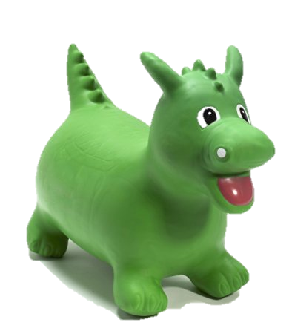  short  vowel
Sort by long or short sound – helps children to look for the single short a grapheme or to see it in combination with other letters to make a digraph with a long sound. | 
cat | cape | rain
cake | play | eight
they | vain | straight
vein | great | at
rat | chat | mad
acorn | plate | train
tray | weight | maze
paint | day | crayon
sleigh | grey | rag
ant | animal | alphabet
apple | attic | dad

